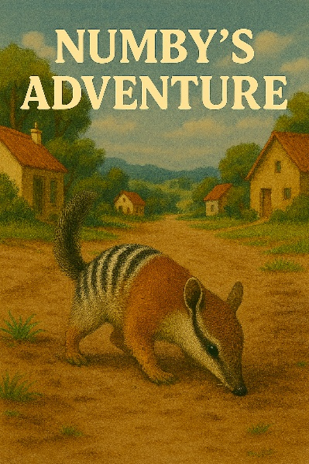

Written and illustrated by Daniel Trudinger

Dedication
To Project Numbat for helping save this
endangered species.

Acknowledgment
Thanks to “Arts for kids” Hub (again!) and SketchArt for the drawing inspiration and to James (again!) for teaching me how to write “meeting tales”

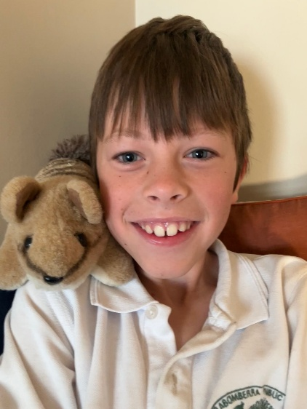
About the author
Daniel is an 8-year-old boy who discovered numbats at 3 years old. He still likes numbats and is working towards saving them by collecting cans to raise money for Project Numbat. When Daniel grows up he wants to be a zoologist to help the numbats even more.

Daniel’s other interests include reading, (he has read all the Harry Potter books,) and public speaking - last year got into the finales of Rostrum! Daniel also loves sports, particularly, soccer, tennis and long-distance running.

Daniel lives in Canberra with his mum, dad and two younger sisters, Ella and Zoe. One day he hopes to play professional soccer for Barcelona.
Day 1

Hello, I am Numby. I am a middle-aged numbat, old enough to have experience but not too old. One day, a zoologist called Daniel came to pick me up, from my home in Drylands National Park.

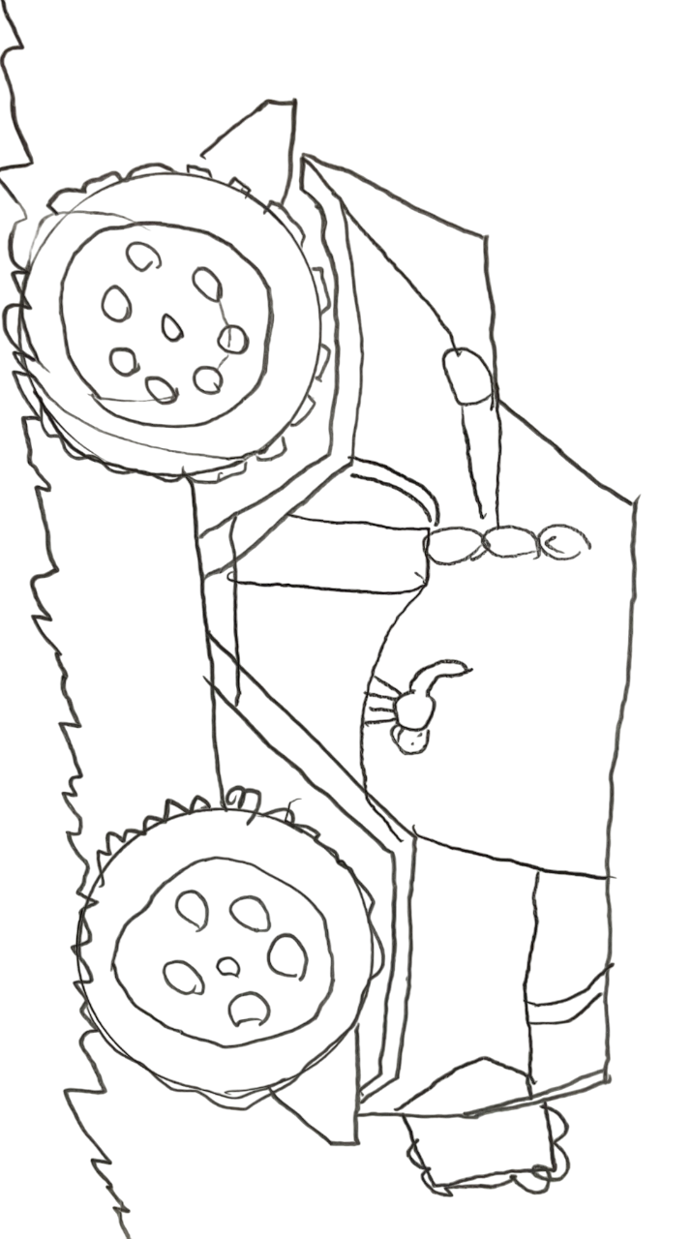
We got in an ancient machine (Numby didn’t know this was called a car!). The ancient machine was huge. It was quadruple or more the size of me. When we got in, the ancient machine roared (which was the engine turning on) and then it started to move. It was a rocky ride, and I wondered where we were going. Eventually we got somewhere completely different. I was confused.
Page 1
Daniel put me down on the dirt. I started sniffing around. I was getting hungry. I had only had 1,000 termites that morning. Where’s my other 19,000 that I need for the day?

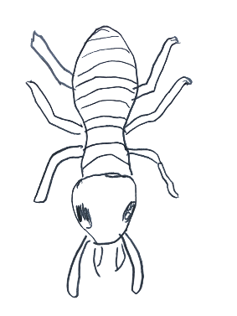
Just then, a new zoologist called Louie came out with a big machine with termites in it. I ate them all up, and then more appeared. I ate the new termites and then even more appeared. “Wow” I thought, this machine produces infinite termites! I ate so many and then I felt full and went to sleep.
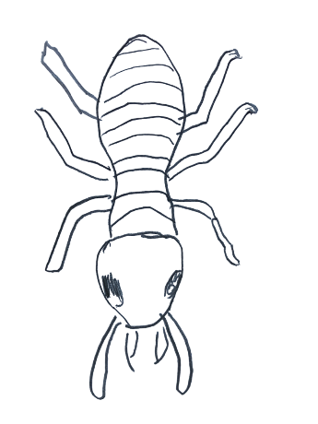
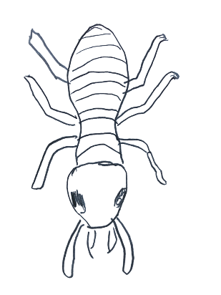
Page 2
Day 2
I was scared when I woke up. I didn’t know my surroundings and this was the time foxes came out. They are dangerous to numbats!

Daniel took me to another big machine. This time it was sleeker and had a T on the front (It was a Tesla). This time it made a purring noise instead of a roar. I liked this ancient machine better.

It took me to a lab and inside the lab there was a glowing blue thing. A person named Ella gave it to me and unleashed foxes (of course these were not real foxes, they were clever robot foxes).

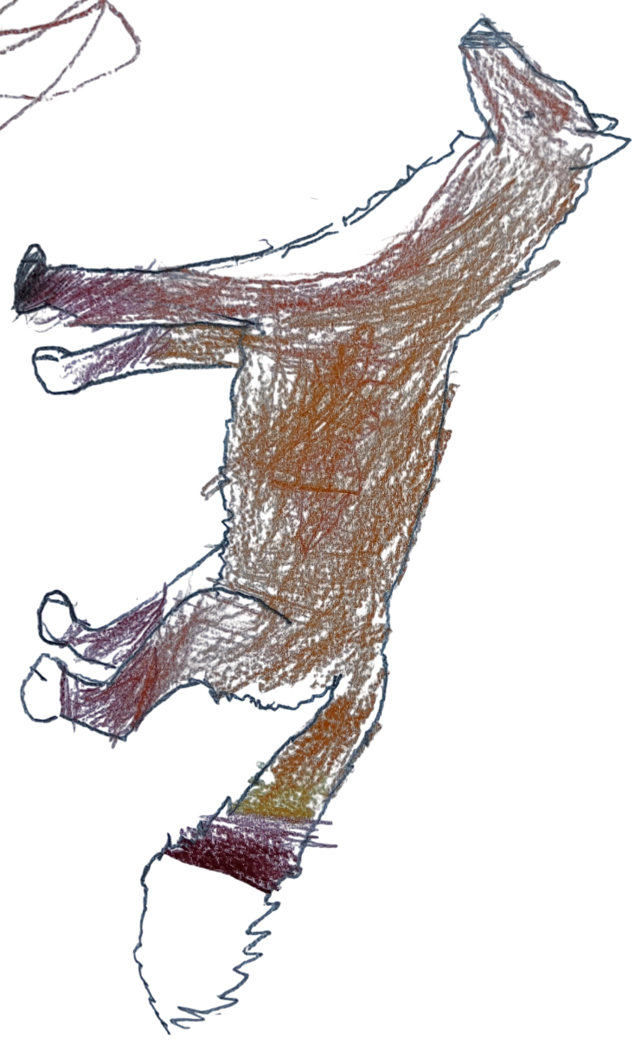
I saw my life flash before my eyes, and then a miracle happened. As soon as the foxes hit the blue thing, they got shot back (It was an anti-predator force field!). That night I stayed at the lab with the termite machine and the predator protector.
Page 3

Day 3
Last night I had a nightmare about the big yellow thing (It was an excavator), it was about to knock down my home but then I woke up.

I was a little bit scared of the yellow thing coming to my home that day. Then I got in an even bigger ancient machine with Daniel. This one had wings. As we got in, there was a big voice and an even bigger roar. I did not like this ancient machine, but then we started flying.

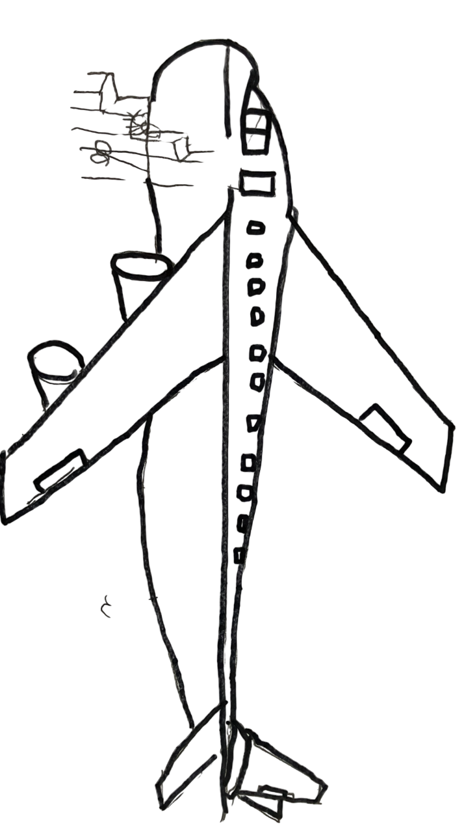
For the rest of the journey it was smooth, and I had space to run around. We flew to a person called Michael, who had a lot of land, and it looked cool. They let me go in there and sniff about. Then Daniel told me that no big yellow things would come because Michael had a lot of private land and that he had donated it to the numbats so that my home would be safe.
Page 4
Also Available:

Also available:

Also available:

Written and illustrated by Daniel Trudinger

Day 4
I was not scared. They even gave me friends—999 of them. The other numbats also had a force field and termite dispensers and we started to repopulate. We are not endangered anymore.

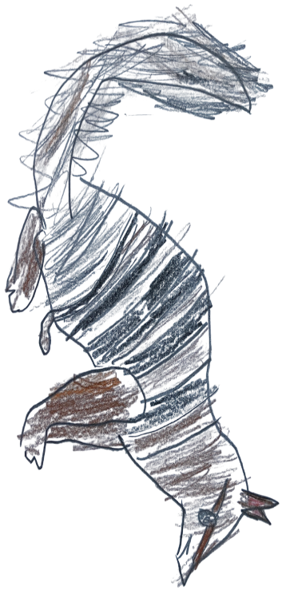
But guess what? Foxes are!

The End
Page 5
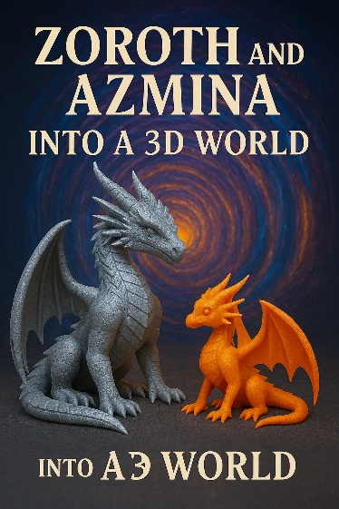

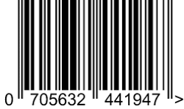
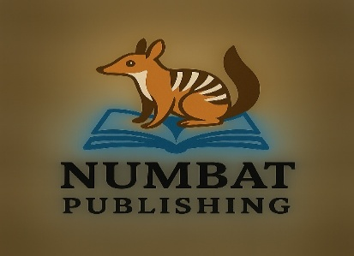
Also available:
A cute animal journeys for a safe home
away form threats to help his species.
Numby’s Adventure

